Vectors- Questions
May 2019 Mathematics Advanced Paper 1: Pure Mathematics 1

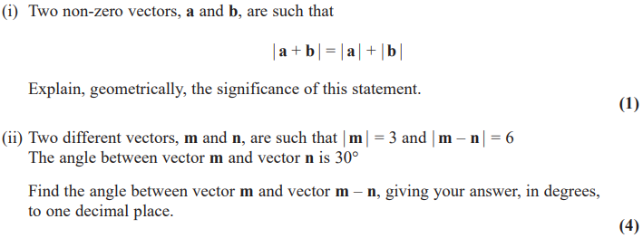
May 2018 Mathematics Advanced Paper 1: Pure Mathematics 1

